Qubikle Development Ltd.

**App Code Name:**

**App Name Suggestions:**

1. Your probable kids
2. Future kids
3. Genetic compatibility Testing
4. iKids
5. iGenetics

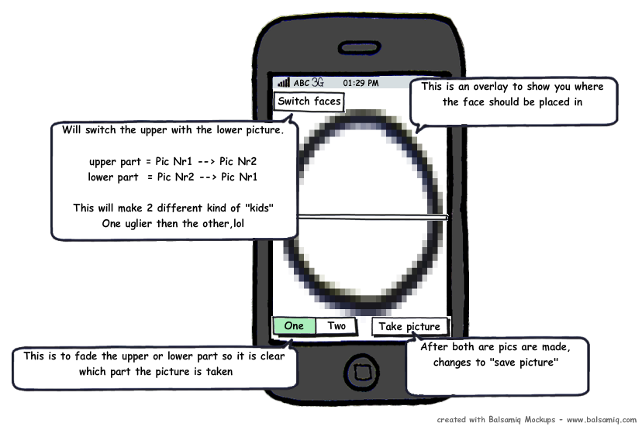**Mockup:**

**Description:**

It is a camera where you take a picture of two persons...one time it makes just the upper half, the other time the lower half pciture....so the upper 50% of the face is from Nr1 and the lower 50% is from Nr2. Some commercial cameras have this build in for other pusposes.

**Required Functionality:**

1. Picture screen split in two
2. Make picture independently of each other
3. Save combined picture
4. Zoom/shift option to fit the picture correctly

**Optional Functionality**

1. Switch screens
2. Color and brightness adjustment
3. Import from local photo library
4. Random kids from in app taken pics
5. Sending as mail
6. Upload to (sites)

**Core Competition:**

1. Split camera (used for other purposes)
2. iSwap faces
3. frankenface
4. Mixup
5. MyNewFriend

**Target Market:**

Kids and teenagers

Age: 12 to 21

**Branding Angle:**

See your future kids…fun application where you can see how compatible you are and how your kids will look like. Competition on website possible for the ugliest and best looking kid.

**Sales:**

Free- You can’t save the pictures.

Paid: Other options available too

First 4 weeks as paid only then when the initial sales streak ends (or when no sales),, release free version

**Required Data: (Pictures), (Text)**

Overlay of a face or a marking spot to let others know in what position to place the head/make the picture.

**Estimated Data Collection Time:**

**--**

**Estimate Programming Time:**